WATER PROJECTS 2013

Early Friday morning, July 12, I arrived in Dili having travelled overnight to Darwin, only to be greeted by rain. I had been told that the wet season had extended much later than normal but was optimistic that by early to mid July it might be over. Sadly it was not, but we could at least travel from Dili to the Bakhita Centre, in the Ermera District, our normal base for the work we undertake. We were however limited in being able to travel to many of the other villages we had planned to visit.
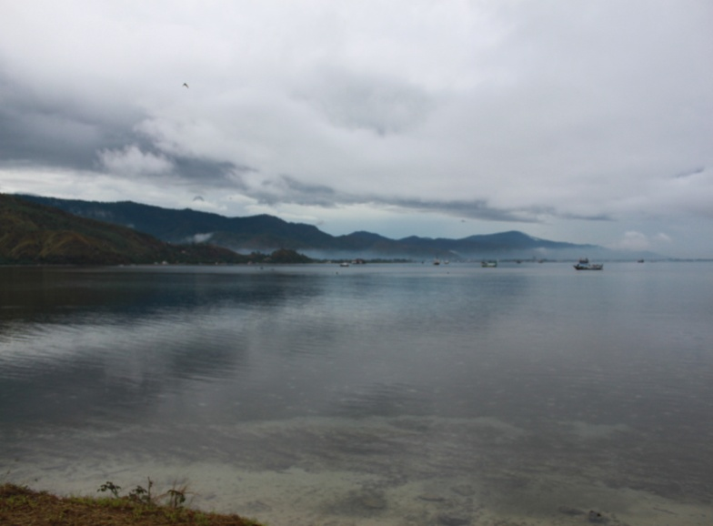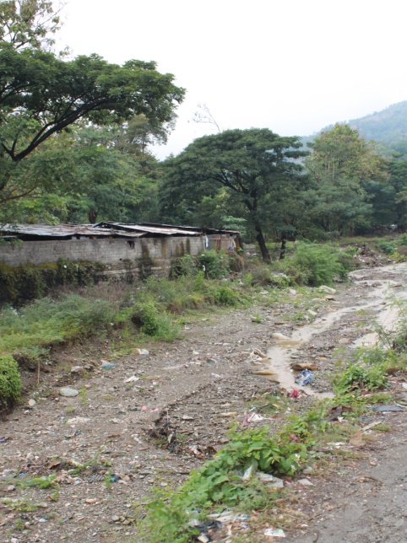
Figure 1: Cloud storms, Leaving Dili Friday July 12 Figure 2: The Impact of the wet season
On Saturday, July 13, I along with Eddie and his team from Bakhita travelled to Suri to look at the preparatory work already undertaken for the toilet block which we had promised when I visited last November. Sauria is a small remote and very poor village. However, in between the rain, the team had been able to make a start on digging the hole for the septic tank and I was able to direct them as to what had to be done for the toilet block overall. The villagers are very grateful for our contributions. They are happy people and have worked hard to cover the tanks we oraganised for them last year.
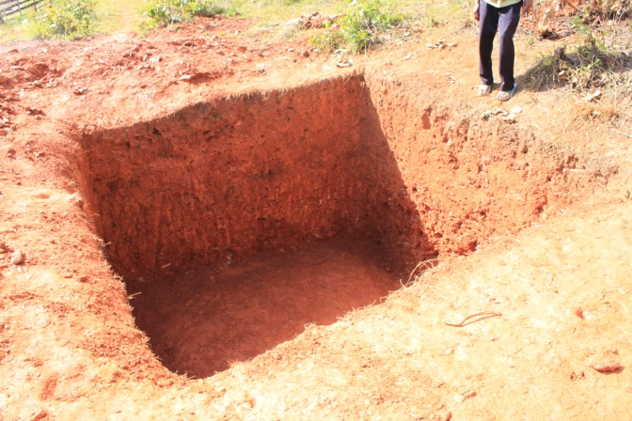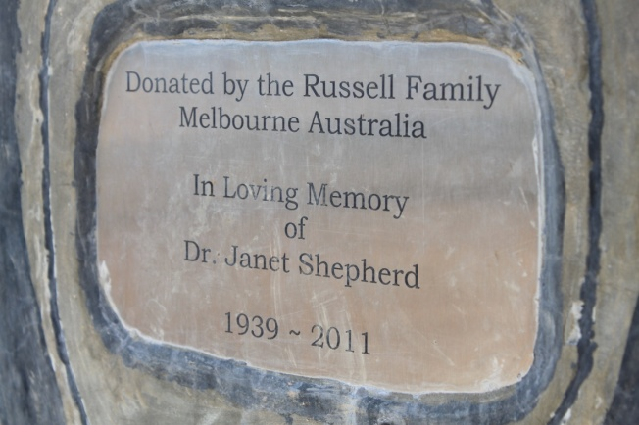
Figure 3: Septic tank Preparation Figure 4: Tribute to the donar of this project
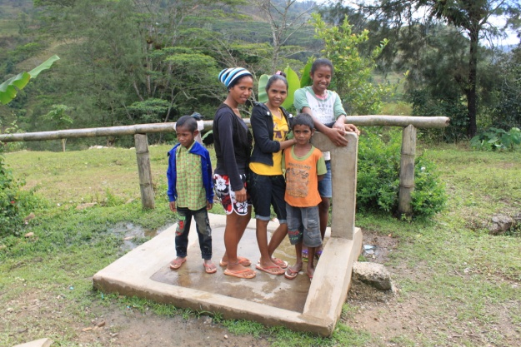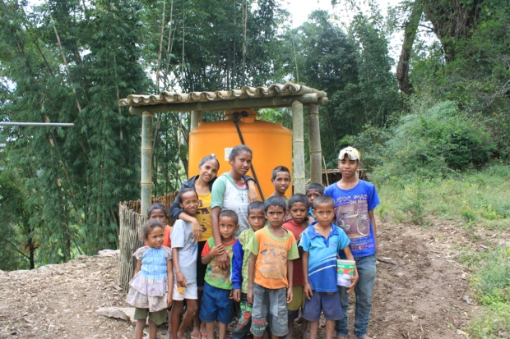

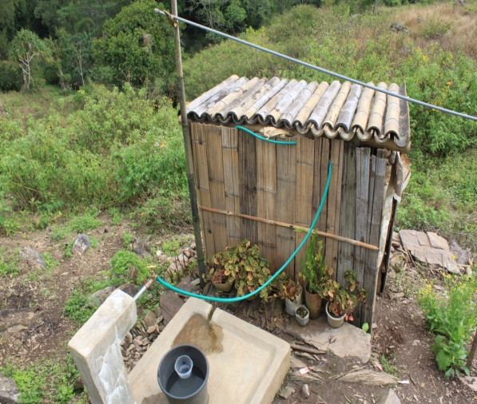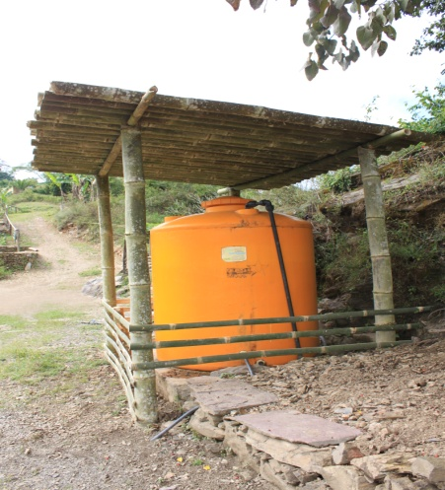
Figure 5-8: Result of last year’s work. Tanks are now covered for protection
While at Suri, I was also able to inspect a proposal to extend the water pipeline we put in place last year to service another 7 families. It requires 1 tank and pipe to run about 600 metres – something that is well within our budget and the ability of the team to put in place.
The weekend at Bakhita was much occupied with the preparation for the forthcoming investiture of a young priest at Letefoho. Letefoho is a large village and the church is the most important building in the village. It brings a crowd of at least 2000 for prayers every Sunday. It has a health clinic, primary & secondary schools, a church and a market, which services the surrounding area. As an extension to our memorial for Xavier Mugavin, I assisted with the installation of a pressure pump, 3 hand basins and 3 hot water services in the local priest’s house. This will assist accommodate visitors to the parish. Letefoho is only normally a 25-30 minute drive the Bakhita Centre. However the road conditions were such that it took us 2 hours to get home that evening! Since my last visit in November, the main difference I see in the area we visit is the vast deterioration in the roads, particularly the roads to the many villages.
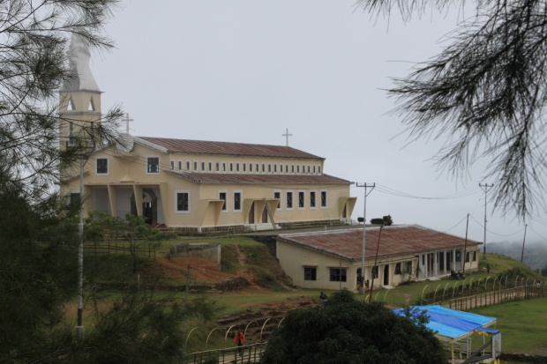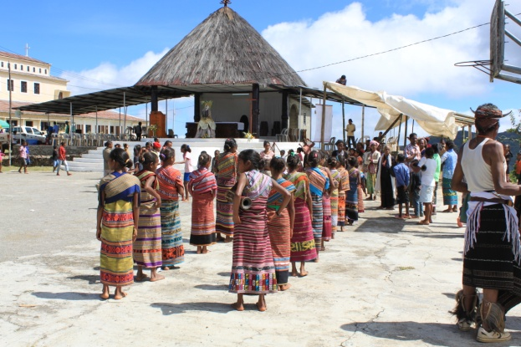

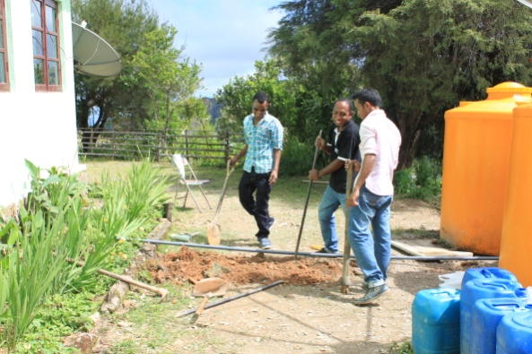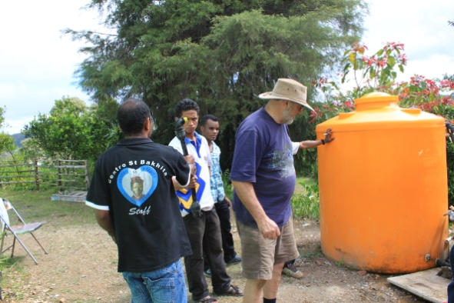

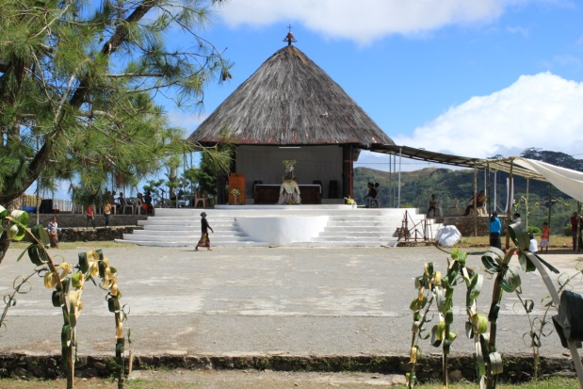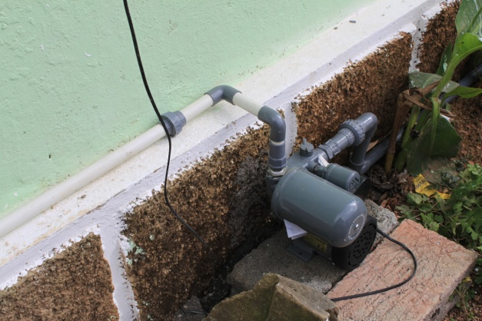
Figures 4-9: Letefoho chapel and preparations for celebrations

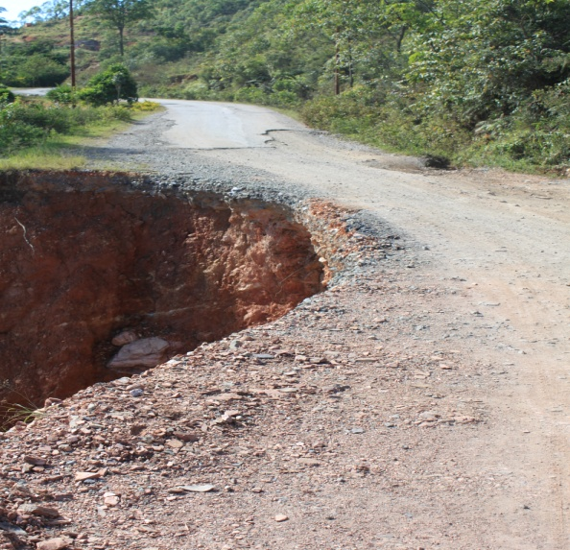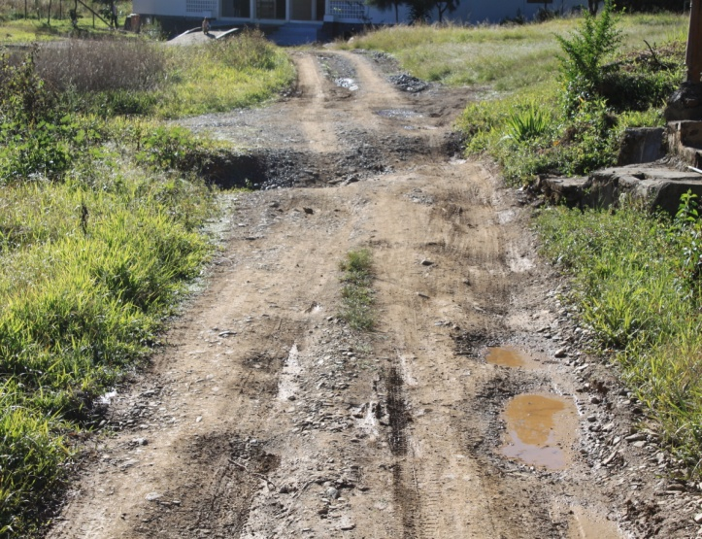
Figure 10-11: Typical road conditions

Returning to Dili on the Monday then back to Darwin and then home, I feel confident that the Bakhita team will complete the work on the toilet blocks proposed for the school and the community centre at Suari and that the additional families will have a tap stand closer to their homes. Yve, when she visits the area in August, will be able to check on the progress and determine if further material is required.

Andy Graham
President, WET
July 2013

