Newsletter June 2021

Warm greetings Water East Timor (WET) members, supporters and friends to our first newsletter of 2021. We trust you are all staying safe and keeping well. The devastating Covid 19 Pandemic which entered our lives in 2020 continues and necessitates us to be mindful of the way we do things and go about our daily lives in ways that keep us, our families, friends and community safe.
The recent cyclonic floods and landslides in Timor Leste have caused havoc, devastation deaths and destruction to the country we support. This disaster has come at a time when Covid 19 was doing its best to inflict maximum damage and loss of life to the Timorese people, a horrible double whammy that is hitting the country hard. The number of dead resulting from the floods is 32, with 49 people reported missing presumed dead, 33,835 houses damaged/ destroyed throughout the country and less than 15,000 families have been able to be supported to date. Many individuals do not have the opportunity to buy food or materials in which to repair or rebuild their homes.
Our most recent email to you was to advise you that if you were wanting to donate to the recovery effort and Covid situation in Timor Leste it is WET’s recommendation that you donate money to a Non-Government Organization (N.G.O.) MALUK TIMOR (MALUK meaning your people, kinsfolk family, close friends) - YOUR DONATION WILL MAKE A HUGE DIFFERENCE!
To find out more about the outstanding work Maluk Timor undertakes you can find them at: maluktimor.org
Maluk Timor is supporting and providing frontline services to help, combat and deal with the devastating aftermath of the floods as well as the Covid 19 situation in Timor Leste. I am sure that after you have read about their work you will have no hesitation in donating to them.
Flood water in Dili is receding and has been spared further heavy rains, since the floods Timorese families, neighbours and friends have been helping each other to rebuild. As the flooding retreats from the public eye there will be enduring effects, some of which Maluk Timor seeks to bridge. As national attention turns to Covid 19 the country and health system braces itself for a surge that will stretch the limits of the health care system.
As of 21 May 2021 a total of 33,835 households have been affected across the country and 12,197 across 12 Municipalities have requested and needed non -food and food items. There remains 2734 people displaced in evacuation centres, humanitarian needs to vulnerable groups are needing to be addressed as a matter of urgency.
The active Covid 19 cases number 2,398 (including those amongst the temporarily displaced) and continue to increase daily with the risk of further spread of Covid 19 remaining high. Agricultural areas affected by the flooding has negatively impacted on food security, food prices in the marketplaces have increased enormously leaving many unable to pay their high costs. As from the 30 May the Timorese Government has imposed a State Of Emergency for 30 Days for the whole country in an effort to control and contain the spread of Covid 19.
The United Nations resident Coordinator in Timor Leste emphasised that “it is important to speed up delivery of assistance to Timor Leste at this critical stage to prevent further loss of lives, additional damage to essential public services, infrastructure, stop the spread of diseases and for those who still remain in emergency centres”.
PLEASE GIVE GENEROUSLY
MEET THE AUTHORS – FUNDRAISER

WET conducted a wonderful and successful fundraising event “MEET THE AUTHORS” on 21 February 2021 at Cafe Lava. Our guests at the fundraiser were International and Australian bestselling author Ms Heather Morris and Warrnambool’s very own Dr Bill Bateman, in conversation with former ABC Melbourne radio presenter Mr Derek Guille. We were fortunate to have a full house at the event with such a star studded cast and raised $9000.00 in order for WET to undertake future water and sanitation projects in rural and remote villages in Timor Leste. Sincere and grateful thanks to our guests for their generosity of time and self, our audience were thrilled to have them with us.

Our thanks also go to local businesses who generously donated goods as prizes in our raffle which was conducted on the day: these are local businesses with a community spirit!

*Cally Hotel
*Capitol Cinema
*The Pavilion
*Sri Agri Kitchen (Sri Lankan Food)

Collins Booksellers generously donated money from each book that was sold on the day!
A sincere thank you also to the manager of Collins, Ms Michaelie Clarke for her assistance in the promotion of the event which was truly appreciated. Thanks also to the staff and management of Café Lava – we really appreciate the effort everyone went to making this day a success.

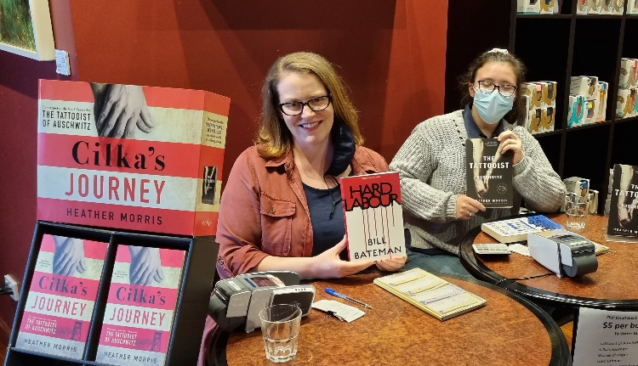

To Individuals who provided donations a sincere thank you for your kindness and generosity.

LAUANA WATER PROJECT 2021: COMPLETED

Eddie De Pina and the Bahkita Water Team undertook this project in the Ermera Municipality, Ermera Sub district, LAUANA VILLAGE. The intention of the project was to provide a water supply to the school and village of Lauana. Children and women were walking roughly 1.5 kilometres up a mountain carrying 5 litre bottles to fetch water from an isolated spring.

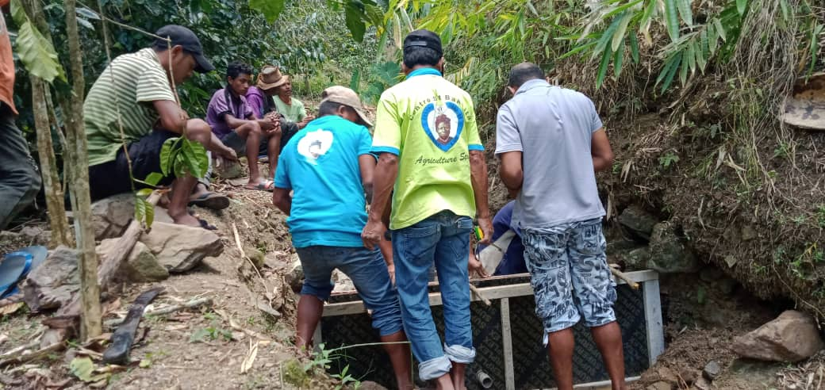
The project involved partially
damming the spring above the village, constructing a concrete reservoir in which to hold the water and then running pipes from the dam to holding tanks above the school, Large tanks were installed at the primary school in the village and from the school the water distribution was provided to other parts of the
village community. Tap stands
were placed both at the school
and at groups of houses.

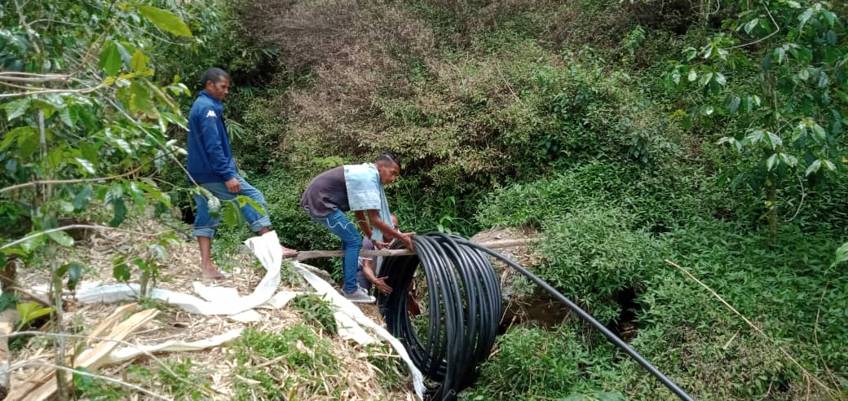
Approximately 30 houses within the village with a population of 210 people benefited from access to clean water and also 503 students at the primary school and preschool. School children from other nearby villages attending these
schools also benefited accessing
clean drinking water.

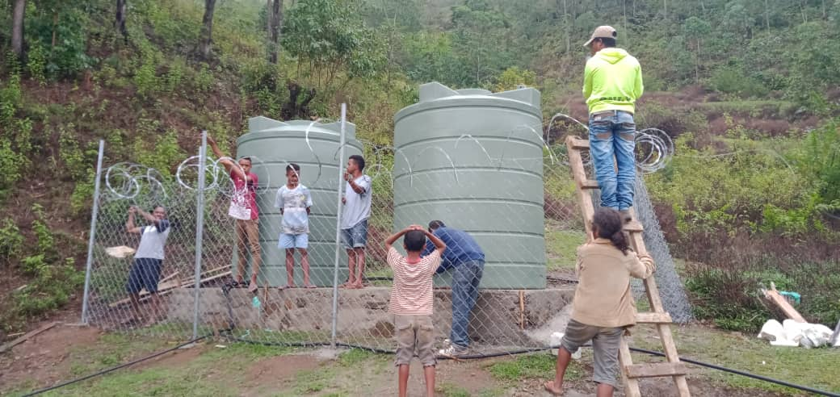
This project was particularly difficult as it was undertaken when Timor Leste were trying to keep Covid 19 at bay. Our gratitude and congratulations goes to Edd ie da Pina and his Bahkita Water Team and the community of Lauana for initiating and undertaking a safe project.

PIZZA LUNCH @ COMMUNITY GARDEN- NOVEMBER 2020

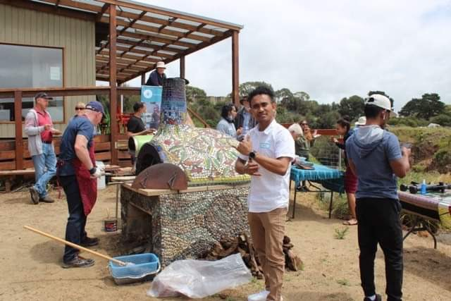
The committee of management (COM) of WET extended an invitation and welcome to the Timorese community who arrived in Warrnambool to live and work for 2 years as part of the Pacific Labour Scheme. A hand of friendship and welcome was extended to them by WET to join us for a pizza lunch at the community garden in November last year, a delightful day was had by members of WET and community garden members who also attended.

The convener of the community garden took several Timorese on a guided tour of the garden which saw a number of Timorese sign up to become members of the garden, many now have their own garden plots in which to grow their own vegetables.

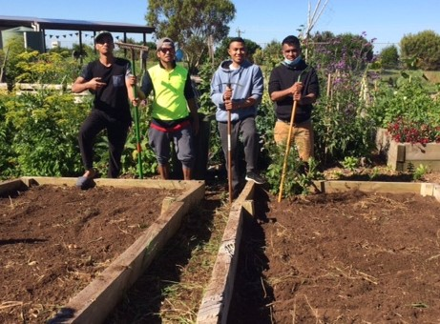
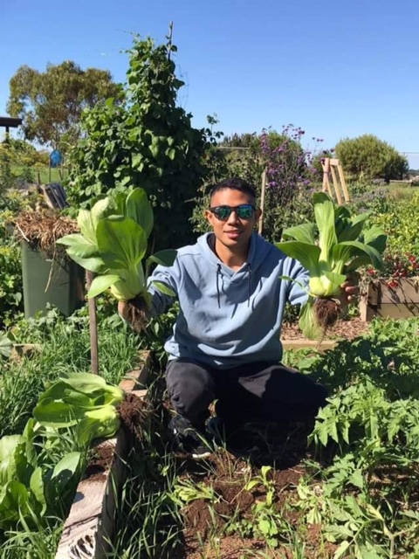

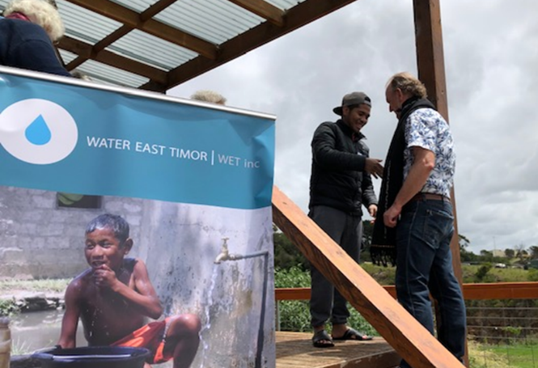
It was also an opportunity for the COM of WET to acknowledge the generosity of a number of individual donors to WET who were present on the day. People from villages where WET had undertaken projects made a Tais, a traditional Timorese textile, with the surname of the donors on them.

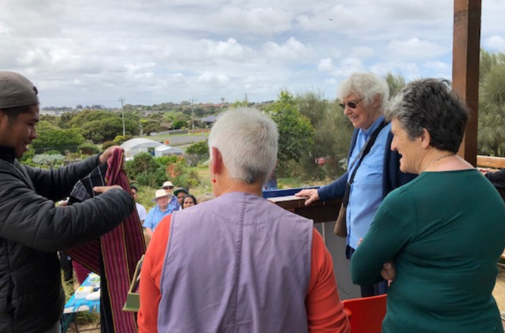
These Tais were presented by Timorese individuals attending the lunch.
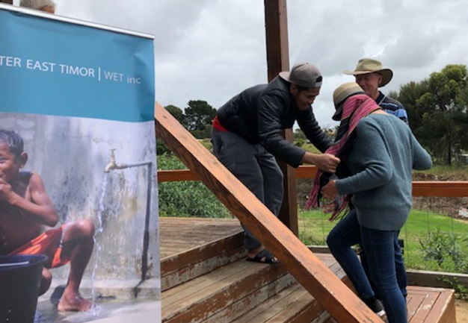

JOIN US:- - SAUSAGE SIZZLE / FAIR @ OUR LADY HELP of CHRISTIANS SCHOOL
TO RAISE FUNDS FOR THE RESTORATIONS IN TIMOR LESTE FOLLOWING THE DEVASTATING FLOODS, LANDSLIDES AND SURGING CASES OF COVID 19:
SELBY ROAD EAST WARRNAMBOOL -25/07/2021 - 9.30AM to. 2.30 PM

Members, friends and supporters of WET along with Father Lawrie O’Toole and parishioners of Our Lady Help of Christians (OLHC) are holding a Sausage Sizzle / Family Fair on July 25 from 9.30 am till 2.00 pm.

The fundraiser is will raise funds to send to the NGO, MALUK TIMOR in Timor Leste to enable them to purchase materials, food, medicines for their frontline workers to distribute to communities affected by the devastating floods and the frightening Covid 19 situation which is currently surging through the country.

Interactive activities are planned with guest stars from our Warrnambool based basketball teams Seahawks and Mermaids and local football team. Activities such as handball and goal shootout, hoop shooting competition will be conducted throughout the time of the fair. Anyone wishing to learn Timorese music and dance may do so as these will be performed in the gym hall.

Please keep this date free and come along and support our endeavours in raising as much money as we can to assist the large number of people of Timor Leste less fortunate than us requiring assistance to get back on their feet.

WARRNAMBOOL ARTISTS SOCIETY OPENING EXHIBITION

The President of the Warrnambool Artists Society, Ms Judy Rauert, has informed WET that due to Covid 19 restrictions the gallery is not permitted to gather more than 30 persons at one time within the gallery space. This small number unfortunately is not viable for the society to request WET to cater for the event and therefore fundraising for this event by WET is not able to take place which is regretful, as it was an opportunity for WET to fundraise from the catering of the opening exhibition and the event itself was always a joyful time. We wish the society a successful opening exhibition.

MEMBERSHIP FEES DUE END OF JUNE -

Be on the lookout for an email from our Secretary Anne Maree Mugavin advising you that it’s time to renew your membership.

We welcome any contribution you have to make towards the smooth and effective running of our association, whether it be coming on board our Committee of Management as a committee member OR being involved in one of our focus group sub committees, many hands make light work and your expertise/knowledge you have to offer will be most welcomed.

If you would like to have a chat and find out further details please feel free to contact our President Greta Perry on 0438 415 661 OR Secretary Anne Maree Mugavin on Email watereasttimor@gmail.com

Yours sincerely
Greta Perry, President
Water East Timor (WET) Inc.

