President’s Report 2023
Welcome Water East Timor (WET) members, supporters and friends to our Annual General Meeting for 2023. Although I cannot be present at the meeting, I am pleased to present this written report of WET activities for 2023.

Our projects this year
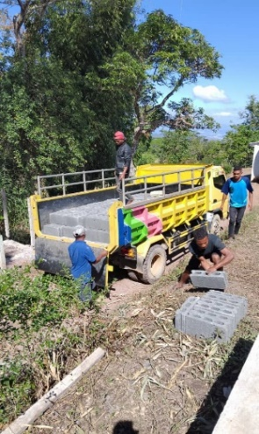
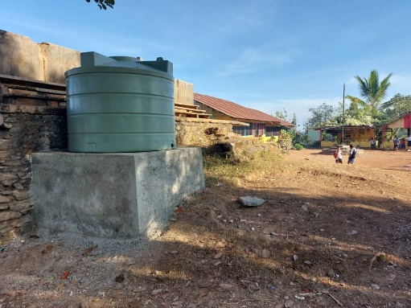
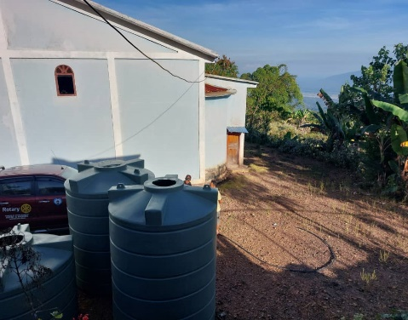
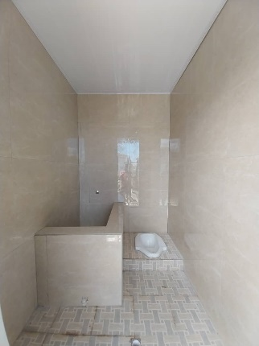
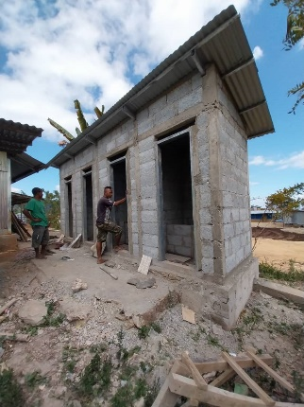
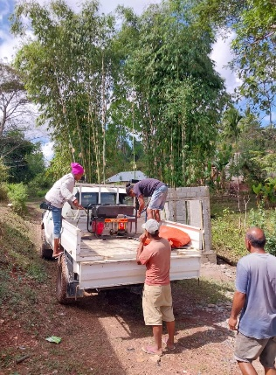
Our completed project this year was water supply for the village of Asulau in Ermera District – total cost around USD $15,500. Approximately 250 villagers, 50 households and a village school with 120 students will benefit from having clean water piped into their village. During WET planning for this project, the President of Timor Leste Mr Jose Ramos Horta committed money towards the building a toilet block beside the school. This was completed and is now functional.

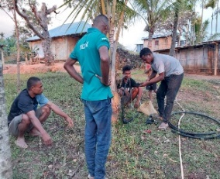

We are fortunate to have committee member Eddie De Pina on the ground identifying rural villages in Timor Leste desperately in need of clean drinking water and sanitation. Eddie provides information to WET on the identification and logistics of potential projects, along with costings, the number of villagers who will benefit from the project. Consideration is always given to how to optimise the reach of the project and scope in schools and nearby villages. The gratitude of the villagers within the village inspires us to continue with what we do.
We have also commenced planning for our next project in the village of Ramelau – one of the highest points in the mountains of Timor-Leste. The village has a primary school, and it is estimated the project will benefit around 1,000 people.

Fundraising activities
Fundraising for water projects has been COVID-constrained over the past few years, so we are just getting back into the swing of sourcing funds for new projects. In addition to our support from the Rotary Club of Warrnambool East, we raised the following funds:
- $3,185 from supporting the Warrnambool and Districts Artists’ Group with catering for their annual Art Show
- Over $1,600 from a Bunnings BBQ
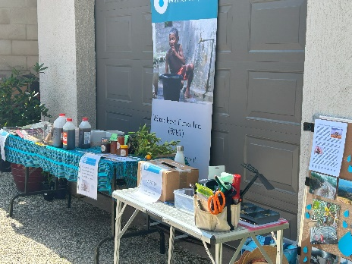
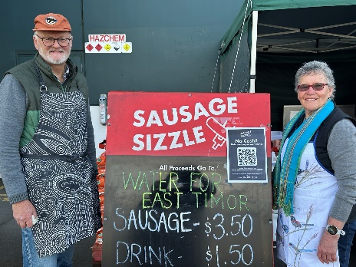
- Around $600 from a garden stall at a Warrnambool Rotary Garden Open Day (which included the garden of one of our Committee members)

Administrative activities
We have applied for DGR (Designated Gift Recipient) status with the Australian Tax Office. If approved (likely January-February 2024), this means that donations to WET over $2 will be tax deductible. Prior to being approved by the ATO – and because we expend our funds in another country – we had to go through a rigorous process to be approved by the Department of Foreign Affairs and Trade (DFAT). We are pleased to report that we have been officially endorsed by DFAT and it only remains for final sign-off to be given by the ATO.
We are also in the process of creating a WET-based Google Workspace for Non-Profits, which will provide us with shared storage space for our files, as well as WET email addresses for committee members.

To our hard-working WET committee
Thank you for your dedication and application to tasks requiring action in 2022/2023. This has been outstanding and has made for the smooth and effective running of our organisation. The work on collating all the necessary paperwork required to apply for DGR Status was a monumental achievement. A huge thank you goes to Julie Kean who took the lead in this exercise for without Julie’s determination and expertise I think we would still be labouring with the application. We now await approval from the Taxation Office to make WET a Tax-Deductible charity!!

To all our loyal members of WET
A sincere thank you for your continued support in renewing your membership, attending our fundraisers, and assisting us to continue to assist Timorese living in rural and remote areas to access clean water within their village.

To Warrnambool East Rotary Club
We are grateful to have the support and generosity of this fine organisation in assisting WET to raise funds required to undertake and complete projects. Their financial donations are always gratefully accepted and appreciated!

WET Social Media
For up to date information about our activities and projects, check out our website at www.watereasttimor.org or look for our Facebook page, Water East Timor.

And finally…
I have decided not to stand for President or membership of the WET Committee in 2024. I have served aa a COM member of Water Timor-Leste since 2015 and as President since 2018. I am taking a break from these responsibilities to refresh myself and to give myself an opportunity of exploring the world around me. I wish WET continued success in the provision of WASH projects to the truly worthwhile people of Timor Leste and thank each committee member for their dedicated contributions. I shall remain a supportive member of WET.
All the best to our Committee, Members, and the people of Timor-Leste for 2024.
Greta Perry, President and Chair
21 November 2023

