WATER FOR EAST TIMOR (WET) GIVES THE MOST PRECIOUS GIFT
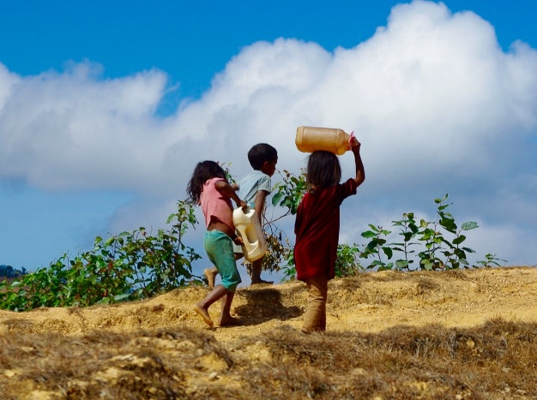
The sun rises early all year round in Timor Leste. So do the children who have domestic chores to complete before heading to school. Maria Lourdes Soares is eight years old, and she lives in the mountains in the small village of Lauana. Along with her younger brother Paulo, Maria Lourdes collects the family’s daily water supply from a natural spring 1.5 kms up the mountain from her village. Between them they carry four 4L plastic containers weighing about 16 kg down the mountain to their home.

Collecting water in the mountains is arduous, so the water that is brought from the spring is precious. In the villages of Timor-Leste spring water is primarly used for drinking and cooking, and personal hygiene takes second place. Hand-washing is not customary and simple communicable diseases are common in Maria Lourdes‘ village. COVID-19 has recently added a whole new health and sanitation risk.

A small group based in Warrnambool Australia is aiming to change this. Inspired by a desire to improve living standards and health outcomes for Maria Lourdes and Paulo and other children in remote rural villages, Water for East Timor (WET) raises money in Australia to fund at least one rural village water and sanitation project in Timor-Leste each year.

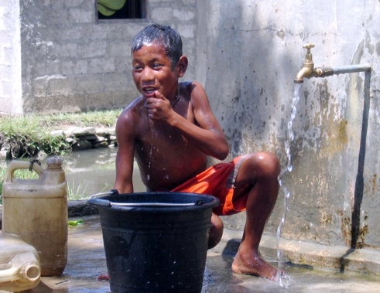
WET is one of many philanthropic organisations, NGOs, and faith-based organisations facilitiating water access projects in Timor-Leste. While the WET organisation is small, the impact is huge for the estimated 8,000 – 10,000 people who have benefited from WET activities over the past 7 years.

To manage its water and sanitation projects, WET works in partnership with the Catholic Church’s Bakhita Centre in Ermera District. Over the past few years of collaboration the Bakhita Water Team has built up considerable WASH expertise, under the leadership of Timorese local, Eddie De Pina. Eddie’s family fled Timor Leste in 1975 when he was a young boy and he spent most of his school years in Perth WA. Eddie returned after independence to help rebuild his country and the WET projects are a demonstration of his deep commitment to this task.

Water projects are not easy to implement in Timor-Leste. Challenges of topography and weather combine to frustrate the best laid plans. Almost half of Timor-Leste's 15,000 sq/km land area has a slope of greater than 40 degrees, making it scenically beautiful but extremely difficult to implement infrastructure programs. Added to this are increasingly unpredictable wet seasons where both rivers and mountain sides can turn into torrents of water so that roads are impassible, sometimes for months at a time.

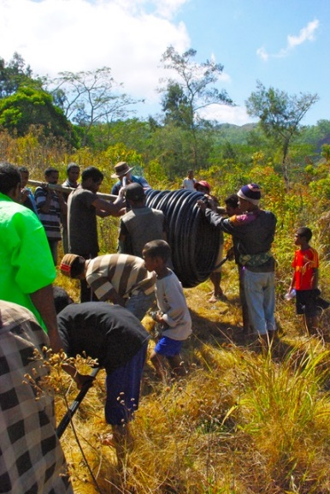
Given this, water infrastructure needs to be simple to implement and easy to maintain. WET projects rely on gravity fed systems that don‘t require pumps or electricity. A typical project might involve damming a natural spring and laying pipe to holding tanks which then lead to tap stands that service small clusters of houses. Simple, and effective.

WET projects are only approved and undertaken after extensive consultation with each recipient village. To receive WET funding the village leaders must commit to providing the construction labour and ongoing maintenance for the water infrastructure.

The Bakhita Water Team works closely with the community to design and implement each water project. The team receives technical support from a small team of plumbers based in Warrnambool who oversee the design and planning of the water system. In the past this has involved one of more technical advisers travelling to Timor-Leste to scope the project, and an unexpected outcome of COVID-19 is that this support is now provided remotely. The Water Team has developed knowledge, skills and expertise to a point where WET has confidence in their capacity to implement projects to specification, on schedule and on time.

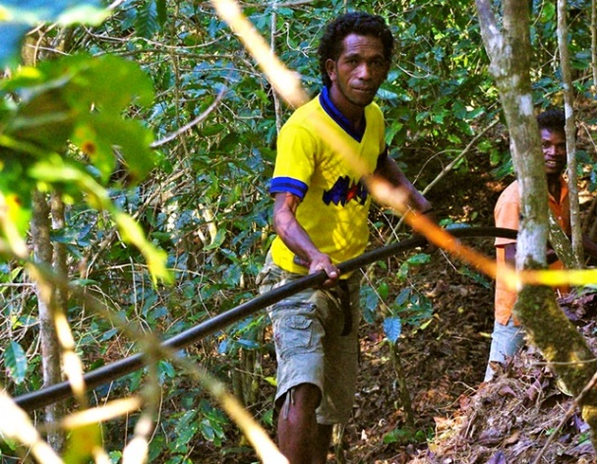
By involving the village community in each project, WET is able to ensure local ownership and therefore the sustainability of the water solution. Skills development and the health and safety of the project team are high on the WET agenda.

At the end of the day, one of the WET measures of success is how many Maria Lourdes‘ and Paolos can arrive at school on time because they are freed up from their early morning water-collecting duties.

If you would like to know more about Water East Timor’s past and current projects or you would like to support the work we undertake, you can become a member of WET for just $20. We welcome your support!! You can visit us at: watereasttimor.org

To date, Timor-Leste has remained relatively free of COVD-19 with only very small numbers detected early in the pandemic. The Government of Timor-Leste has been very proactive in testing, quarantine and community education. However local sanitation continues to be an issue.

