PAUL HARRIS FELLOW
The presentation of a Paul Harris Fellow is The Rotary Foundation’s way of expressing its appreciation for a substantial contribution to its humanitarian and educational programs. It is named for the founder, Paul Harris, a Chicago lawyer who started Rotary International with three business associates in 1905.
Rotarians often designate a Paul Harris Fellow as a tribute to a person whose life demonstrates a shared purpose with the objectives of the Rotary Foundation.
The Rotary Club of Warrnambool East awards a Paul Harris Fellow to both members of the club and to community members. In June 2013, the club awarded a Paul Harris Fellow to Eddie De Pina. While it was not possible for Eddie to be present at the club’s annual changeover dinner when such presentations are made, Eddie was able to be connected via Skpe and could hear and see what was happening at the dinner in Warrnambool.
Past President Rotarian Ray Welsford prepared and presented the following citation for Eddie:
In colonial times, the island of Timor was divided between the Dutch (west) and the Portuguese (East). Along with much of the Netherlands Indies, West Timor became part of Indonesia. After decolonisation, Portuguese Timor declared independence in 1975, but was almost immediately invaded and annexed by Indonesia. There followed a long period of persecution and deprivation.
In 1999, following United Nations intervention and the installation of a military peace-keeping force including Australia, Indonesia relinquished control. There was further strife with insurgents and militias supporting Indonesia, but on 20 May, 2002, Timor Leste became an independent sovereign state.
The Rotary Club of Warrnambool East first became involved very early in the Nations life, making a significant cash donation to a buffalo breeding project in the 1999-2000 Rotary year. Various donations and involvements continued through succeeding years, but it was towards the end of the 2005-2006 year that the real work started. An address by Dr Noel Bayley about the work being done at the Bahkita Medical Centre in north western Timor Leste resulted in Andy Graham, Darren Smith & John Taylor making the first of several trips.
This is where, Eddie de Pina, tonight’s recipient of a Paul Harris Fellow recognition comes in.
Eddie was twelve in 1975 when Indonesian troops invaded his homeland of East Timor. Along with his parents he fled. Arriving in Australia the family resided in Perth, where Eddie attended school and worked for a number of years.
Having lost members of his family in the atrocities, Eddie never forgot his home country. He was determined to do what he could and, once the independence movement took hold in 1999 he returned to Timor.
Amongst the devastation, Eddie worked with whomever he could to start rebuilding community services and infrastructure in the remote district of Ermera.
Fourteen years on East Timor has much to thank Eddie for. Eddie’s philosophy has always been to foster, encourage and provide education for local people to be part of the rebuilding of their country. Eddie’s work has seen the Bahkita Centre develop from a simple community group to a thriving establishment with education facilities, horticultural & farming enterprises and a health care facility that is showcased as a model service.
Projects supplying fresh water to the villages in the district of Ermera have been made possible with financial donations from many in south west Victoria, including the Rotary Club of Warrnambool East, and the skill and time donated by tradespeople from around Warrnambool.
The impact of having a water supply available to families in their village encouraged the volunteers to source funds from a wider group of donors. Hence the formation of WET in 2012. Eddie’s work is now the linchpin of WET”s work in East Timor. He liaises with community leaders, organises supplies & along with the water team from Bahkita, works in the field with the WET project team. He claims only to be a truck driver!
Eddie Pina is one of those people that you don’t meet often in your life, but when you do they are never forgotten.
In recognition of his enormous contribution to the success of the Bahkita and other projects of such importance to his people, the Rotary Club of Warrnambool East is honoured to present a Paul Harris Fellow Recognition to Eddie.

In July when Andy Graham, President of both WET and the Rotary Club of Warrnambool East, travelled to Timor Leste, he presented Eddie with his Paul Harris Fellow (three emblems of appreciation: certificate, medallion and pin) one evening at the Bahkita Centre in the presence of Eddie’s fellow workers.
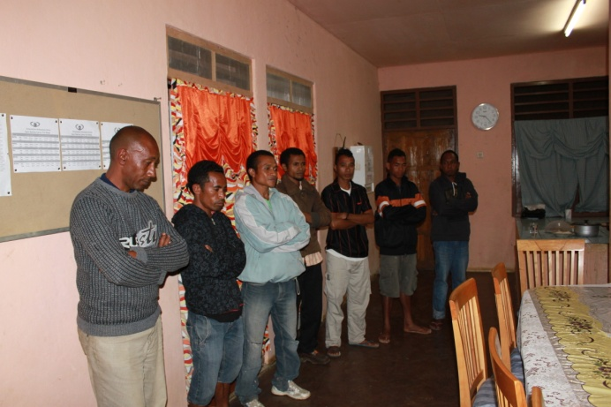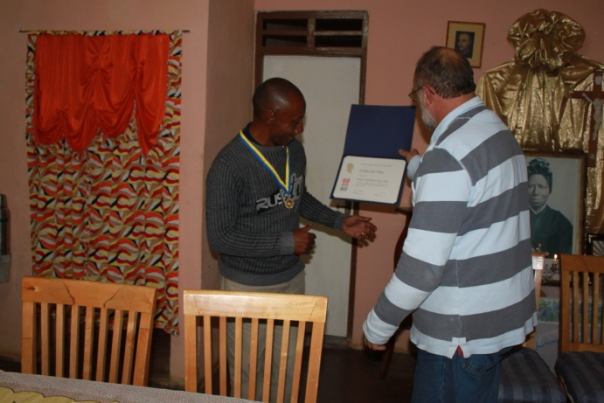
Eddie was very humble in his acceptance. He has never won an award before. We congratulate him for his efforts and his commitment to world understanding and peace and in particular to his people of Timor Leste.

