Newsletter - October 2022

Warm greeting WET members, friends and supporters to our second newsletter for 2022, I trust you and your families are keeping safe and well.

WARRNAMBOOL AND DISTRICT ARTISTS SOCIETY ANNUAL EXHIBITION AND AWARDS
We kicked off our 2022 fundraising efforts with catering duties for the opening of the Warrnambool and District Artist Society Annual Exhibition and were delighted to be back catering at this terrific event after a couple of COVID years lay-off. A new feature of the event was the inaugural WET award to the artist who had featured water in their painting. The award was judged by our Timorese member Polly Da Costa and the prize being an original Timorese textile (Tais) and a year’s membership to WET. The winning painting chosen by Polly was a painting created by Judy Rauert. Congratulations Judy!

VOLUNTEER EXPO
The Warrnambool City Council conducted a Volunteer Expo on 20th August at Emmanuel College. The idea of the expo was to highlight and bring to the attention of residents of Warrnambool and Districts the various community associations with which individuals may wish to become involved as volunteers. Committee members Julie Keen and Greta Perry attended along with our Timorese member Polly Da Costa. We met many people who were not familiar with Water East Timor (WET) and what it is that we do. We were satisfied that we reached many people. It was a good promotional opportunity to bring to people’s attention the great work the association membership does for others who do not have access to clean water and who live in a country with limited access to such a valuable resource!

VISIT TO TIMOR LESTE
In September of this year I was fortunate to visit Timor Leste for the first time and be present in the remote village of Taurema where our most recent water project was completed. What a mind and heart opening visit it was!! During the descent of the plane into the Capital Dili, it became evident to me as to how mountainous the island is. Mountain range after mountain range after mountain range continued throughout the landscape.
The journey from Dili to Taurema approximately 150 kilometres, took around 6 hours due to the extremely poor conditions of the roads. Our committee member and head of the Bakhita Water Team, Eddie Da Pina was our driver on the journey and navigated the insurmountable pot- holed and destroyed road from Dili to the village.
The project funded a new basic supply water system to the village of Taurema from a secure spring, supply pipeline (2 km) to 4 x 5000 litre holding tanks; reticulation to 15-20 supply points within the village and the school. The project funded all infrastructure, transport to site (remote mountainous area) of the tanks, all pipes, fittings, timber, cement, sand, aggregate; construction costs (fuel for generators), some minor administrative costs (e.g. communications) associated with construction/project management. The project did not fund direct labour costs. All labour was provided as in-kind village contribution, but did fund food and drinking water for local labour.
Primary Outcome: Equitable access by all 250 villagers to safe and secure, piped water supply through water tap points located through the village and handwashing facilities at the school. There are also two expected secondary outcomes: (i) Increase in school attendance by children involved at present in water fetching activities; (ii) Reduced incidence of water borne diseases, particularly those afflicting infants because of the reticulation of water from a safe and secure source (spring).
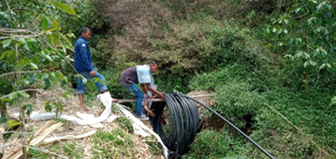
I will be presenting the story of my trip to the village of Taurema at our Annual General Meeting on 15 November @7.30 PM at the Warrnambool RSL. It would be wonderful to have you there.
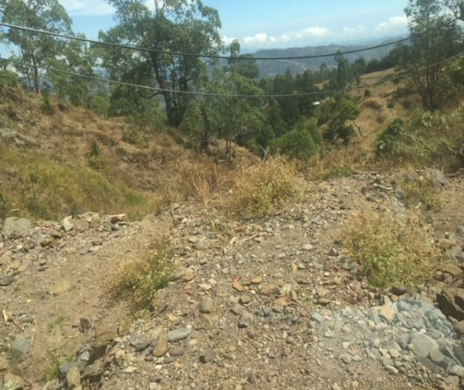
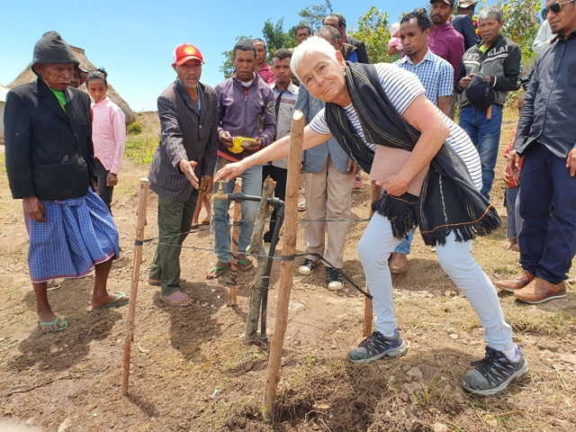
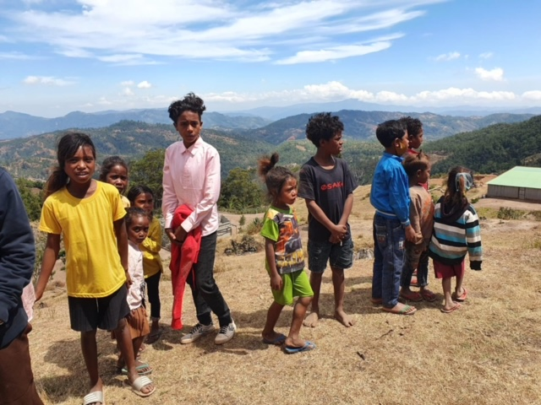
Roads! Laying the pipes.

Excited children! Greta turned on the water!

WANNON WATER “RIPPLE EFFECT” GRANTS.
As mentioned in our newsletter in April of this year, WET applied for a grant called “Ripple Effect” which was being offered by the local water authority, Wannon Water. Our committee of management member and Treasurer Geoff Spencer put his hand up to apply for the grant on behalf of WET. Geoff’s hard work on the application was successful and WET receive $1000 towards our next water and sanitation project in the rural village of Asulau. Geoff and fellow committee member Michael McCluskey will be representing WET at the celebration and grant presentations on the 19 October. We thank Geoff for his brilliant efforts and Michael for attending and representing WET at the presentations.

ANNUAL GENERAL MEETING:
Please find attached an invitation to our Annual General Meeting. I hope you can join us.
Yours sincerely,
Greta Perry
President, Water East Timor

